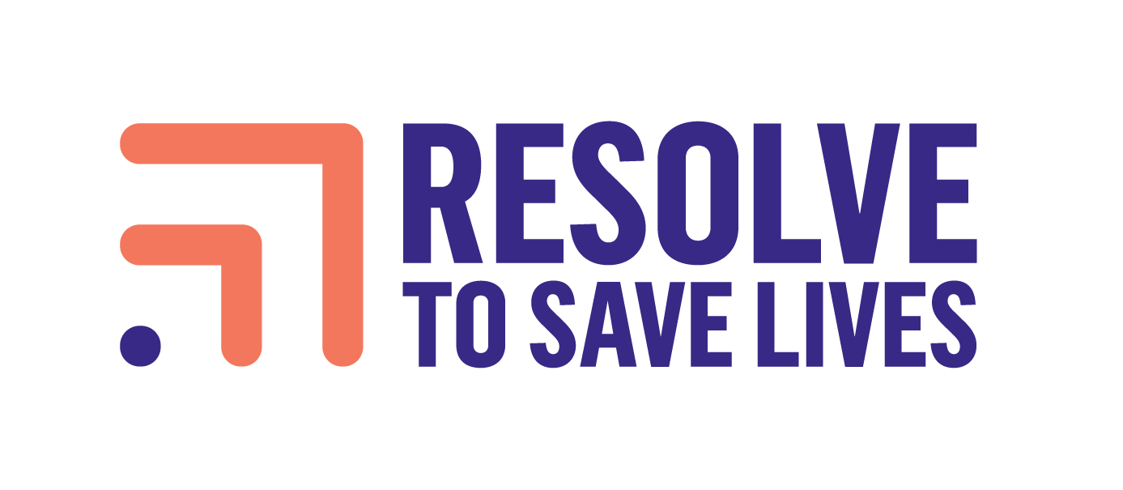
85 Broad Street, Suite 1626
New York, NY 10004
(332) 282-1495
www.resolvetosavelives.org

