Hypertension Health Care Facility Checklist (baseline visit)
Facility name: _______________________ Region/District name: ________________  Facility type: _______________________ Facility hours: ______________________ | Facility supervisor:  ________________  Reviewer:  ________________  Date:  ________________
Facility staffing (N=number)
Physicians/Med Officers (N):___ Nurses (N):____ Pharmacists (N):____ CHWs (N):____
New HTN patients registered in prior month (N):____ Avg daily HTN patients seen (N):___
Total HTN patients registered (N) to date:____ Total Catchment population (N):___
Is the HTN treatment algorithm displayed for staff to reference? □ Yes □ No
1 | BP measurement
1.1 | Number of functional (F) and non-functional (NF) BP devices |  |  |  |  | Digital: F_____ NF_____  Manual: F_____ NF_____
1.2 | Frequency of BP device inspection (digital) / calibration (manual) |  |  |  |  | □ 6-monthly □ Annually □ Not done
1.3 | BP measured for all adult outpatients who come to the clinic |  |  |  |  | □ Yes □ No
1.4 | Location of BP measurement in facility |  |  |  |  | □ Registration area □ NCD clinic  □ Exam room □ Other
1.5 | Observe 5 patient BP measurements (refer to BP checklist below): |  |  |  |  | Circle # out of 5 meeting criteria:
1.5.a | BP measured with patient at rest (sitting quietly) |  |  |  |  | 0 1 2 3 4 5
1.5.b | Proper positioning (back support, arm at heart level, feet on ground) |  |  |  |  | 0 1 2 3 4 5
1.5.c | Correct cuff size used |  |  |  |  | 0 1 2 3 4 5
1.5.d | Exact BP recorded, not rounded (i.e. 142/92 not 140/90) |  |  |  |  | 0 1 2 3 4 5
1.5.e | For patients with initial BP>140/90, repeat BP measured after 3-5min |  |  |  |  | 0 1 2 3 4 5
1.5.f | For patients with repeat BP>140/90, referred to medical officer |  |  |  |  | 0 1 2 3 4 5
2 | Information systems
2.1 | Type of information system used |  |  |  |  | □Paper □Electronic □Both □Neither
2.2 | Patients given unique identifiers (IDs) |  |  |  |  | □ Yes □ No
3 | Treatment (based on review of 5 patient records) Circle # out of 5 meeting criteria:
3.1 | Blood pressure measurements are documented |  |  |  |  | 0 1 2 3 4 5
3.2 | Medication (names/doses) are documented |  |  |  |  | 0 1 2 3 4 5
3.3 | If BP>140/90, HTN medication was prescribed/intensified per protocol |  |  |  |  | 0 1 2 3 4 5
4 | Medication Availability
4.1 | Number of days for which HTN medication prescriptions dispensed |  |  |  |  | 7 10 30 60 90 Other__
4.2 | Drug inventory register maintained and updated |  |  |  |  | □ Yes □ No
4.3 | Drug name*  *Modify drug names for region |  | Current stock  (number of tablets) | Any stock outs in last 3 months? (Y/N) | Monthly consumption (number of tablets) |  | Is stock sufficient for next quarter, i.e.,  is current stock > monthly consumption x3 months? (Y/N)
 | Amlodipine
 | HCTZ
 | Lisinopril
 | Others (specify)________________
5 | Laboratory Testing Availability on Site
5.1 | Creatinine Y / N Electrolytes (Na+/K+) Y / N Urine protein Y / N Other ____________________
6 | Task Sharing (Circle all that apply)
6.1 | BP measurement performed by | Nurses Health Worker/Asst. Physician Other_____________
6.2 | HTN medication initiated by | Nurses Health Worker/Asst. Physician Other_____________
6.3 | Medication refilled by | Nurses Health Worker/Asst. Physician Other_____________
7 | Referral Network and Follow-Up
7.1 | Hospital refers hypertension patients to health centers/posts |  |  |  |  | □ Yes □ No
7.2 | Resistant HTN* patients are referred to specialist |  |  |  |  | □ Yes □ No
7.3 | Follow up appointments are systematically scheduled |  |  |  |  | □ Yes □ No
7.4 | System in place to identify and outreach to patients lost to follow-up |  |  |  |  | □ Yes □ No
*Resistant HTN=Uncontrolled BP (>140/90) after completing all protocol steps or adherent on 3 HTN meds

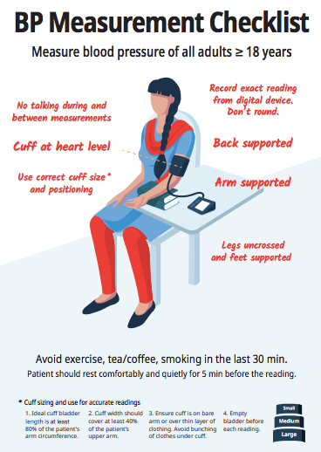

Summary of Supportive Supervision visit

Indicators | Observations | Recommendations
BP measurement
Information systems and patient data recording
Treatment
Medication Availability
Lab Availability
Task Sharing
Referral Network and Follow-up
Other

